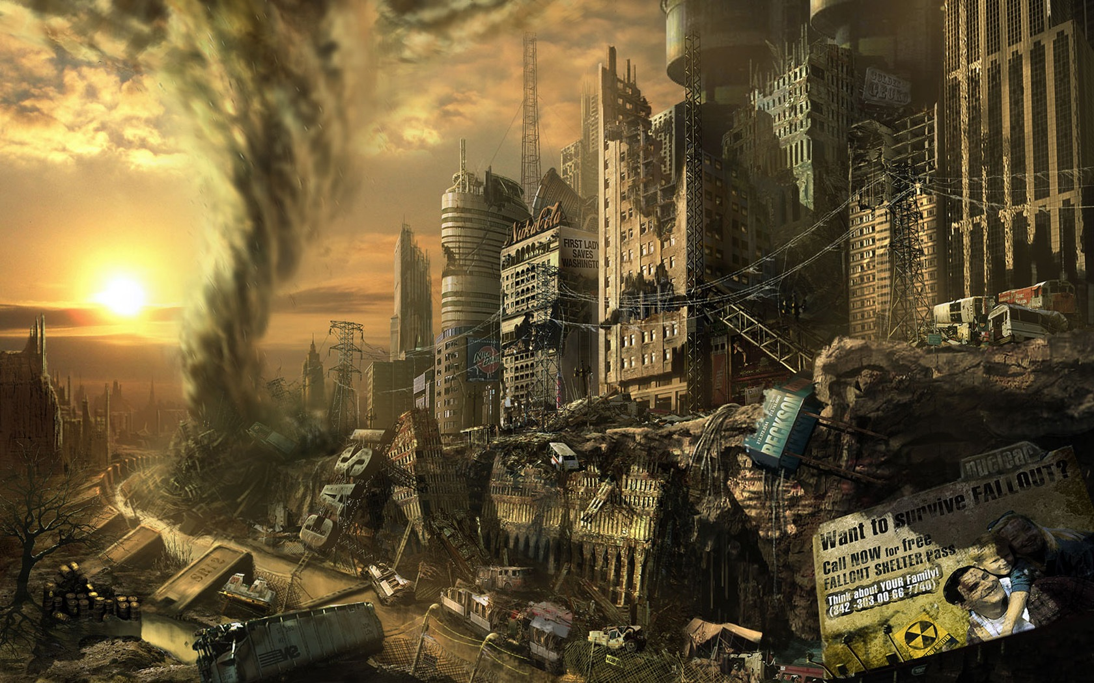

**The Apocalypse is here!**

**1.) Choose what kind of Apocalypse you want**

**(ex. disease, zombie and war)**

**2.) Where is this happening (ex. Russia or a forest setting)**

**3.) What materials you need to survive ( ex. knives, water filters and tools or clothes)**