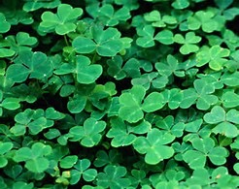
Happy St. Patrick’s Day everyone! Imagine that you were hiking in a forest and all of a sudden you saw a shadow of a small figure coming from behind a tree. You began to be frightened and you figured it was a leprechaun, but was it really? Finish this story.

