One day as you were cleaning you noticed air being sucked towards the base of wall near the cupboard. Perplexed you went closer to investigate. You hold your breath and gingerly peel away at the wallpaper until a huge wrought iron door stands before you.

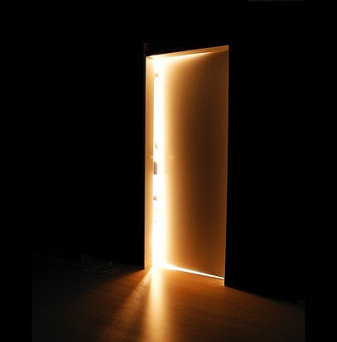
Finish this story. What did you see inside the door? Did something walk out the door? Did you run away?

