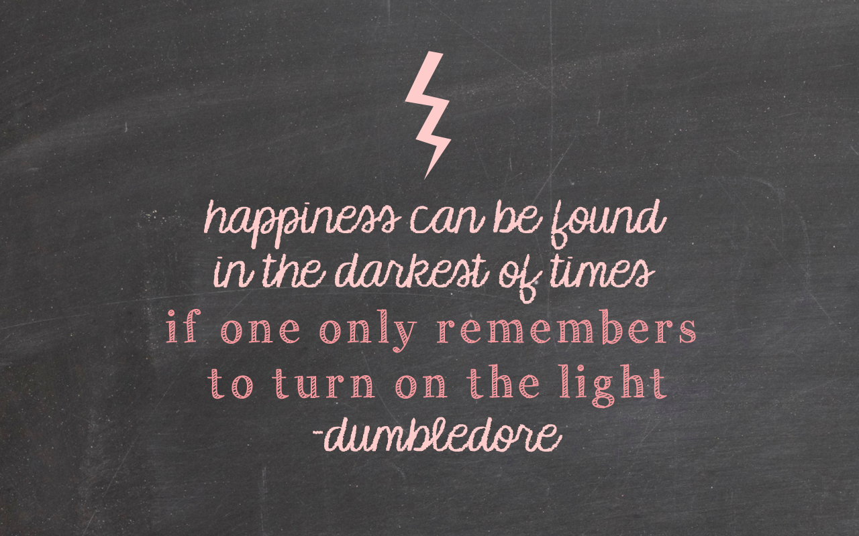
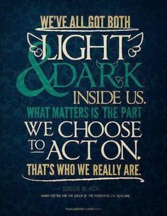
Isabella Dávalos

What is your favorite quote? Why? What does it mean to you? Is it from one of your favorite books? Write the author.

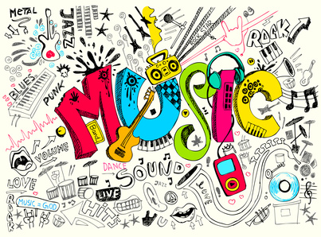

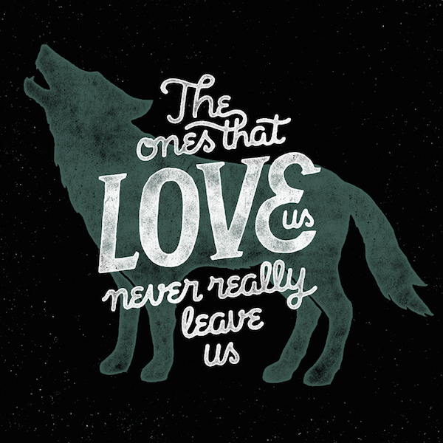
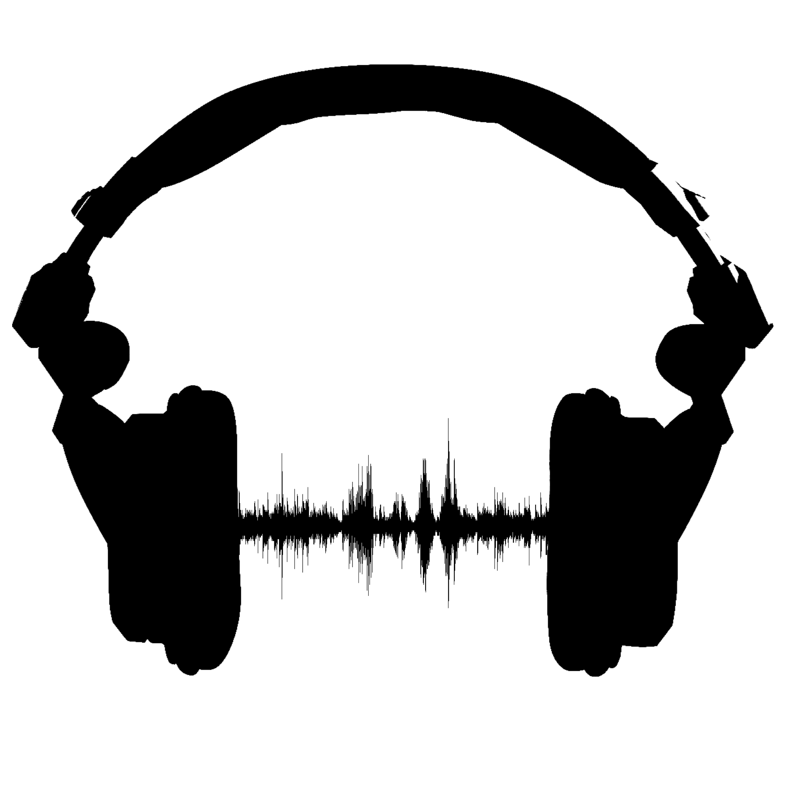
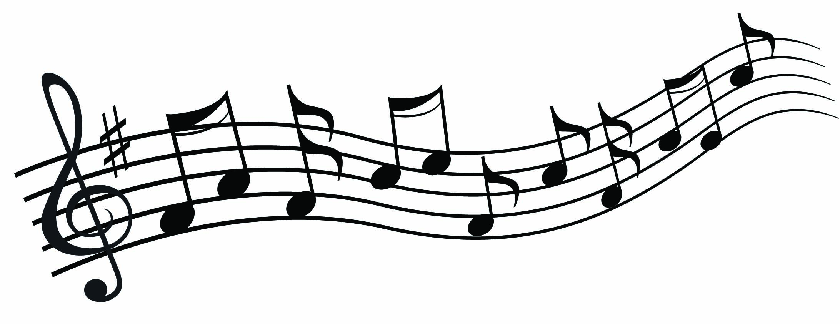
What is your favorite song? Why? Where do you usually listen to that song? Do you listen to it in the car? Do you listen to it at home?

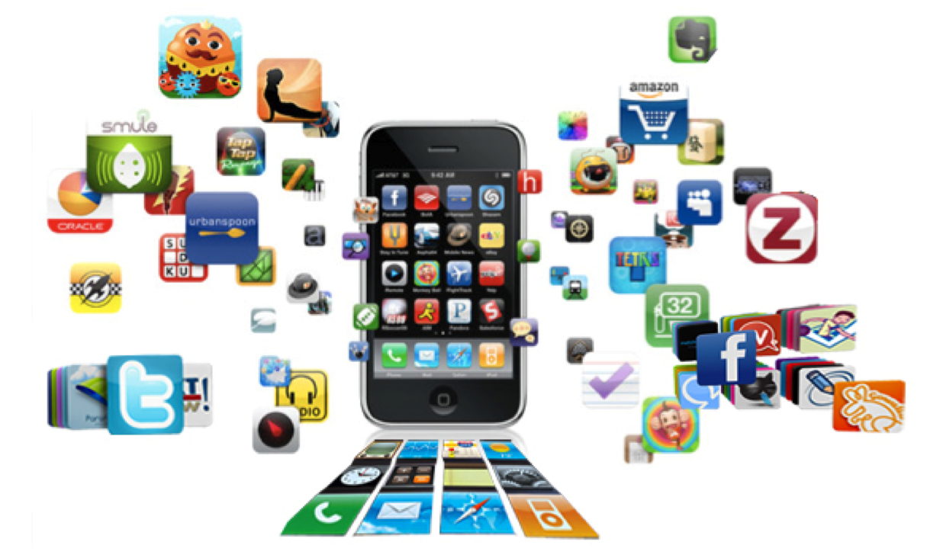

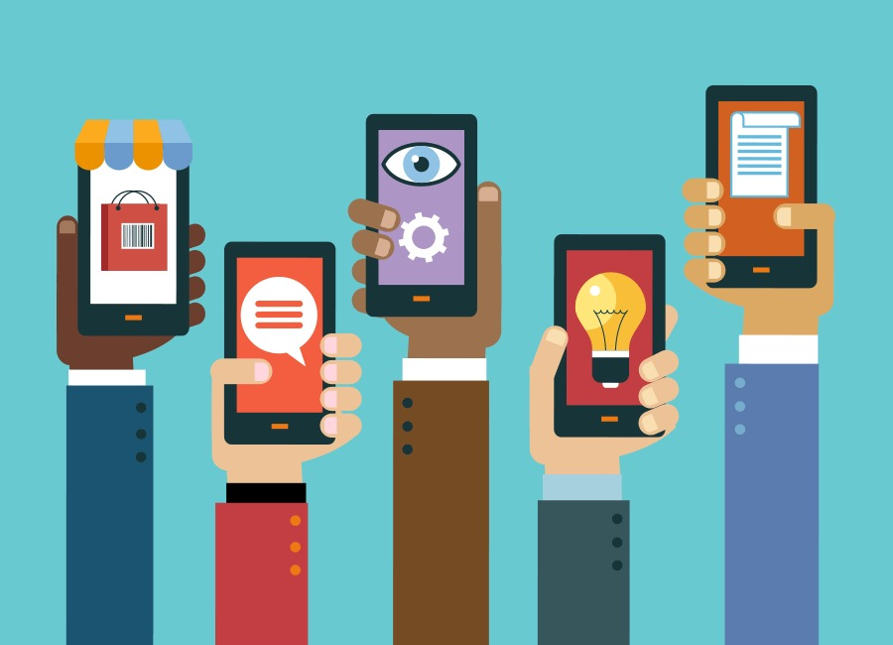
What is your favorite app? Why? How did you come across it? What do you do in that app? Do you play with friends? Do you watch movies or television shows?

