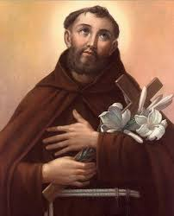
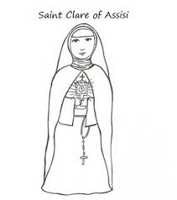
Name__________________________________

All Saints Project
Directions: Each student will pick a saint. Each student will write out a report, create a tri-fold poster (to be displayed in the Narthex of the church), and present their saint in class (using props, costumes, and other items of interest). The rubric and description will be reviewed and signed by parents to ensure all are aware of expectations.
Items to be completed:
- Your Saint:__________________________________________
- T-Chart: Due Friday, October 17, 2014.
- Rough Draft: Due Tuesday, October 21, 2014
- Final Draft (written essay and poster board: Due Thursday, October 23, 2014
- Oral Presentations: 3-4 minutes in length, due October 27, 2014
Written Expectations/Check List (At least three paragraphs)
Introduction:
- ___At least 6 sentences without errors (spelling, grammar, punctuation).
- ___Thesis Statement about your saint/project.
- ___The name of your saint and his/her feast date.
- ___Why you chose this saint (At least two sentences).
- ___Transition word and sentence describing what will be covered in body paragraph.
Body Paragraph:
- ___At least 6 sentences without errors (spelling, grammar, punctuation).
- ___Topic Sentence.
- ___At least one TLQ (Transition, link and quote from research)
- ___Why your saint is important in the Roman Catholic faith and tradition.
- ___What did your saint do, how did he/she live his/her life?
- ___Where was your saint from(where in the world and what time period?)
- ___What is the family history/background of your saint?
- ___Does your saint have a special prayer, or intentions that we can pray to for help?

Concluding Paragraph:
- ___At least 6 sentences without errors (spelling, grammar, punctuation).
- ___Concluding Statement (Restating the thesis-tying all information together).
- ___Recap why this saint is important to you and others.
- ___What did you find most interesting about this saint?
- ___Why do you think your saint is important? What should others know?
- ___Wrap up what you think the most wonderful thing is.
Bibliography:
- ___Include at least 3 sources (One must be a book! I have some in class).
- ___Correctly cite sources on bibliography.
Tri-Fold Poster Board (to be displayed for the entire church community over the weekend):
- ___At least 4 images that represent your saint, or the Catholic Faith.
- ___Written essay and Bibliography on poster board.
- ___Visually appealing, typed, creative, colorful.
- ___Include any prayers, feast days, novenas, etc. that involve this saint
- ___Include your “voice” your own appeal/creativity (MAKE SURE YOUR NAME IS INCLUDED)!
