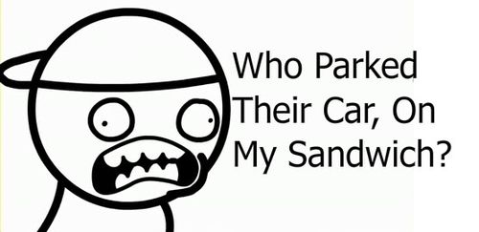

HAVE YOU EVER BEEN SO MAD THAT YOU PUNCHED SOMEONE'S SALAD?

Find out who parked their car on Billy's sandwich

There was a scientist named Jimmy and he discovered a way to modify organisms. As he was testing it on a hamster, it suddenly grew and it is now obliterating the city

Finish the story